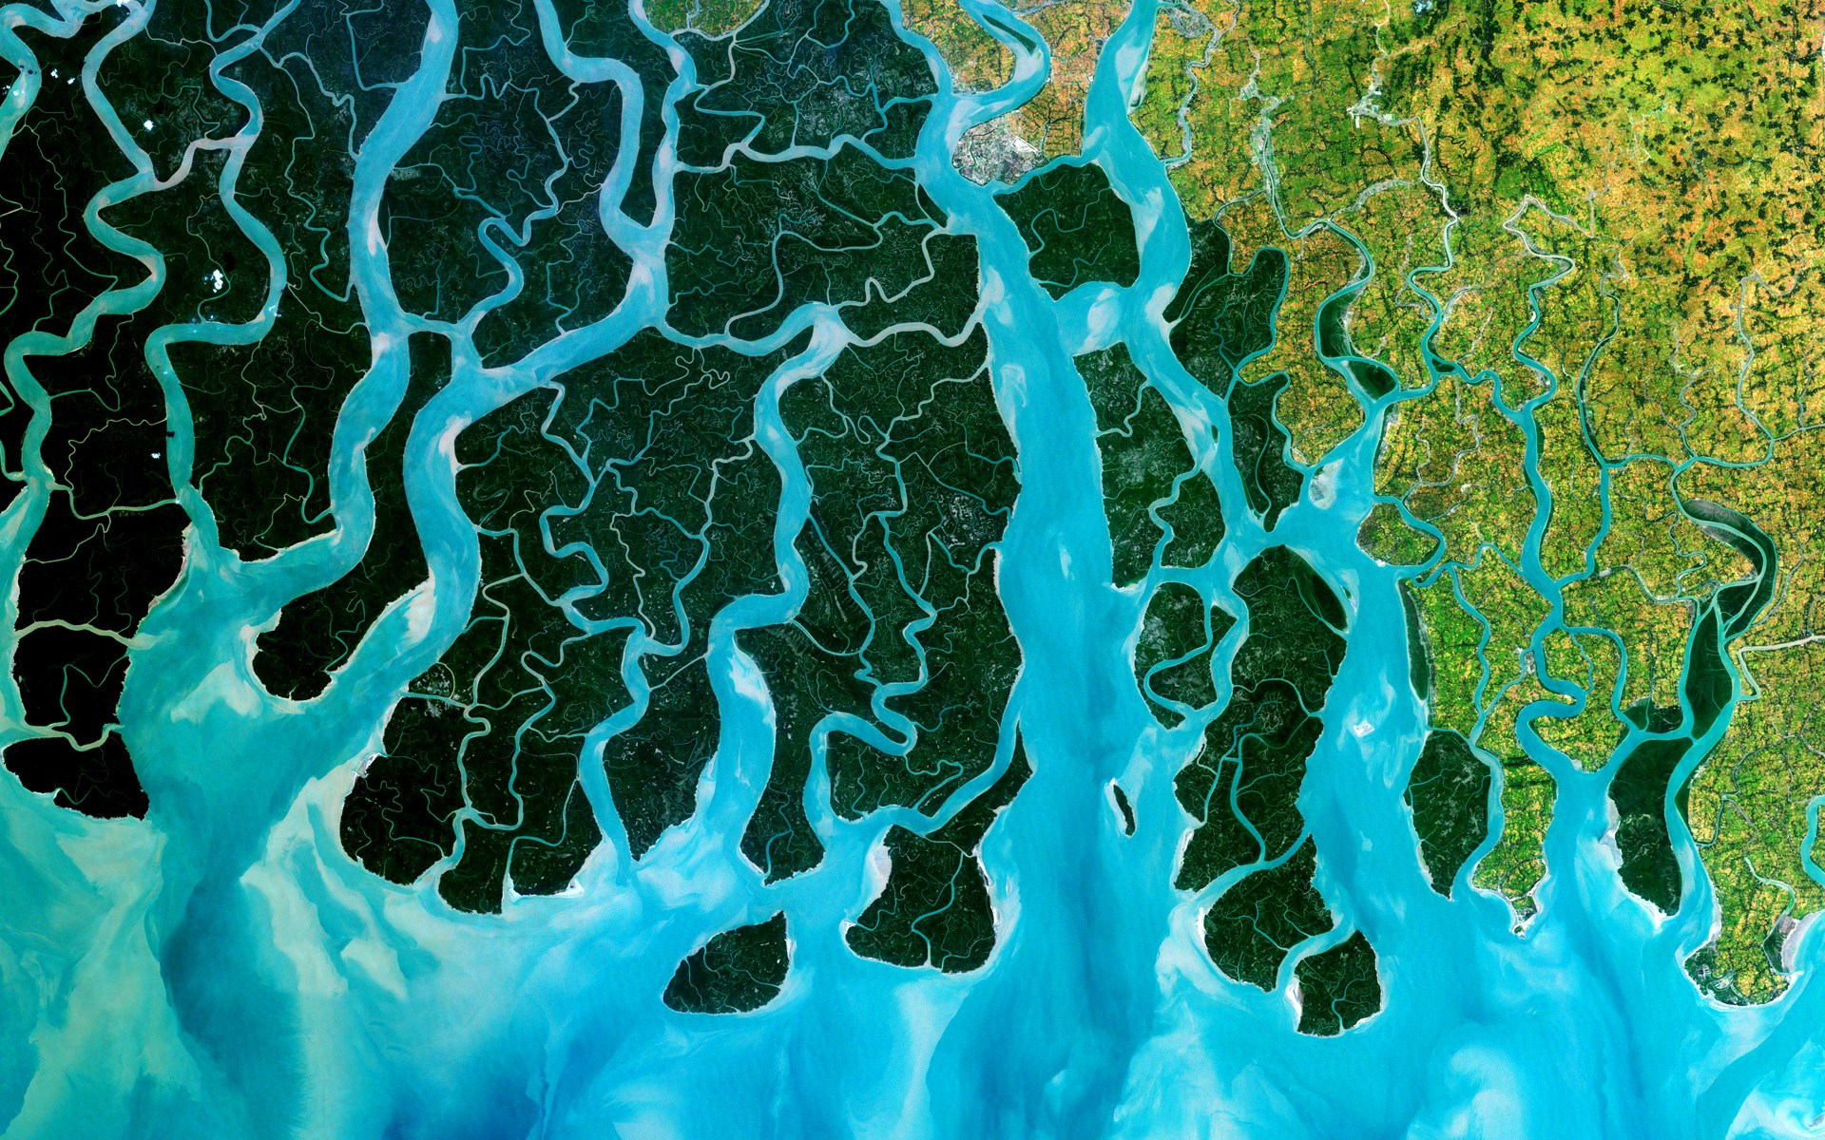
YEAR 7 HASS

The concepts of place, space, environment, interconnection, sustainability and change continue to be developed as a way of thinking and provide students with the opportunity to inquire into the nature of water as a natural resource. The concept of place is expanded through students' investigation of the liveability of their own place. They apply this understanding to a wide range of places and environments at the full range of scales, from local to global, and in a range of locations.
TERM 1 UNIT OUTLINE – GEOGRAPHY - 2019
Year 7 - Geography Unit Outline – Term 1, Semester One 2019
Water and the World
Week | Notes | Lesson 1 | Lesson 2 | Lesson 3 | Lesson 4
The classification of environmental resources (renewable and non-renewable) (ACHGK037)
1 |  | Lesson for setting expectations for classroom/introduction to HASS/icebreakers etc  Weekly Learning Intentions:  Week 1 Learning Intentions:  1. Define the study of Geography.  2. Understand the key concepts of Geography.  3. Describe skills used in the study of Geography. | Learning Intention (LI): Introduce Geography and SPICESS Key Concepts (KC)  Success Criteria (SC): Can recall/define the definition of Geography. Able to list and provide examples of SPICESS. | LI: Introduce course – what is to be studied in Geography this term – Water and the World, Place and Liveability.  SC: Able to explain why the study of geography is important with examples. | Year 7 Transition Day
1 |  |  | Suggested Lesson Activities:  Intro. Geography and SPICESS PowerPoint (HASS Drive)  https://www.youtube.com/watch?v=5FVgg_u3auA  Concept map of key geographical concepts with definitions and examples  GLOSSARY – Definition of the study of Geography and they 2 branches of geography (human and physical)  Suggested Resources:  SCSA Concepts Diagram  SPICESS concept map Handout | Suggested Lesson Activities/Resources:  Introduction to Geography and SPICESS PowerPoint and SPICESS Student Table worksheet (Learning Area Drive) | Year 7 Transition Day
Week | Notes | Lesson 1 | Lesson 2 | Lesson 3 | Lesson 4
The quantity and variability of Australia's water resources compared with those in other continents (ACHGK039)
2 |  | LI: Introduce Water in the World topic by starting with the classification of environmental resources.  SC: Students to know what a natural resource is.  Students to understand the difference between renewable and non-renewable resources. | - LI: Understand process of the Water Cycle and it’s key elements (PERTIC)  SC: Able to label a diagram of the water cycle and list the processes involved (PERTIC) | - LI: Learn about the types of Precipitation and their characteristics.  SC: Able to list and define the types of precipitation. | Catch Up Lesson
2 |  | Suggested Lesson Activities:  - Define ‘environmental resources’.  - Define ‘renewable, non-renewable resources and continuous resources’.  Construct a table on file paper using a red pen or pencil and a ruler, list examples for each type of resource.  Page 72-73 of Pearson HASS WA 7  Resources:  Resources Worksheet (Learning Area Drive) | Suggested Lesson Activities:  - The Water Cycle – define what the water cycle is and look at the key elements of the water cycle.  - Look at each process of the water cycle, such as PERTIC. (Precipitation, Evaporation, Run-off, Transpiration, Infiltration, Condensation)  - Discuss and brainstorm the human impacts and how humans interact with the water cycle.  - Link the water cycle to the big idea of quantity and variability of water resources.  - Look at a diagram of the Water Cycle | Suggested Lesson Activities:  - Complete an RIQ 321 – Topic: The Water Cycle  - Complete a table. Draw table using a red pen or lead pencil and a ruler.  Pearson HASS WA 7. (Pages 76-77)  - Look at the types of rainfall – frontal rainfall, orographic rainfall and convectional rainfall.  - Complete the table. Draw table using a red pen or lead pencil and a ruler.  - Complete Activity 9 page 79, using Source 5.3.7 | Catch Up Lesson
  Renewable  Resources | Non-renewable Resources | Continuous  Resources
  Type of Precipitation | Explanation or key points
  RAIN
  HAIL
  DEW
  SNOW
  Type of Rainfall | Explanation or key points
  Frontal Rainfall
  Orographic Rainfall
  Convectional Rainfall

Week | Notes | Lesson 1 | Lesson 2 |  | Lesson 3 | Lesson 4
The quantity and variability of Australia's water resources compared with those in other continents (ACHGK039)
3 |  | - LI: Understand the variability of water resources in Australia and other continents around the world.  SC: Able to describe the quantity and variability of water. | LI: Understand water scarcity and the different types of water scarcity.  SC: Define and provide examples of Water Scarcity around the world and in Australia. | LI: Learn about the significance of Water Basins, their impact and how they developed.  SC: Able to describe with examples what a water basin is. |  | LI: Learn about the concept of a water footprint.  SC: Able to describe what a foot print is, with reference to a case study.
3 |  | Suggested Lesson Activities:  - Recap and review the definition of ‘water’.  - Define the terms quantity and variability, plus define and understand the names of the Worlds Continents. Mapping Skills: Incorporate direction. E.g. the direction of Australia from Africa  Look at the concept of groundwater. Discuss the advantages and disadvantages of groundwater. Why is groundwater a renewable resource?  Define the term aquifer. Discuss where the world’s aquifers are located.  Resources:  Water Variability PowerPoint  Pearson HASS WA 7. (Pages 78-79) | Suggested Lesson Activities:  - Water Scarcity – look at types of water scarcity. Page 90-91 Pearson HASS WA 7.  - Case Study – Water scarcity in Africa.  - Define the following terms – scarcity, desalination, consumption, water recycling.  - -Reasons for water scarcity in areas around the world  - -Water scarcity in Africa (Page 126-127)  - -Water scarce in west-Asia and North Africa (Page 128-129)  - -Water crises in West Asia (Page 130-131)  - Complete activity 5 a b c page 91 of Pearson HASS WA 7.  - Brainstorm what we use water for. Complete a Think-Pair-Share.  - Look at types of water – Blue Water, Green Water and Grey Water.  - Complete activity 5 page 93. | Suggested Lesson Activities:  - Case Study – The Great Artesian Basin or Murray Darling Basin. Look at the Basin in terms of –  What is it? Why is it there? Significance of it? How it got there? Impact of it.  - Complete activity 5 page 87.  Pearson HASS WA 7. (Pages- 84-87)  - Compare and contrast Variability of water resources in Australia and Africa.  - Students are to complete a brainstorm on each continent using an A3 page of paper. The key idea is WATER AVAILABILITY.  Resource:  http://www.geogspace.edu.au/verve/_resources/2.3.3.3_1_murray-darling_overview_pdf.pdf  http://www.geogspace.edu.au/verve/_resources/2.3.3.3_2_basin_plan_range_perspectives_pdf.pdf |  | Suggested Lesson Activities:  Content:  What is meant by a water footprint?  -Do water footprints vary?  -Coca-Cola and their water footprint (page 10-11)  -Brainstorm – what do you use water for?
Week | Notes | Lesson 1 | Lesson 2 |  | Lesson 3 | Lesson 4
The quantity and variability of Australia's water resources compared with those in other continents (ACHGK039)
4 |  | Handout Task 1 – Water Inquiry | RESEARCH AND/OR LIBRARY AND/OR COMPUTER LESSON FOR WATER SCARCITY INQUIRY TASK | RESEARCH AND/OR LIBRARY AND/OR COMPUTER LESSON FOR WATER SCARCITY INQUIRY TASK |  | RESEARCH AND/OR LIBRARY AND/OR COMPUTER LESSON FOR WATER SCARCITY INQUIRY TASK
4 |  | Explain the inquiry process/begin inquiry task

Week | Notes | Lesson 1 | Lesson 2 |  | Lesson 3 | Lesson 4
5 | Please Note a lesson may be lost to the public holiday. | Labour Day Long Weekend | RESEARCH AND/OR LIBRARY AND/OR COMPUTER LESSON FOR WATER SCARCITY INQUIRY TASK |  |  | Water Inquiry Task Due

Week | Notes | Lesson 1 | Lesson 2 |  | Lesson 3 | Lesson 4
The factors that influence the decisions people make about where to live and their perceptions of the liveability of places (ACHGK043)
The influence of accessibility to services and facilities on the liveability of places (ACHGK044)
6
6 |  | Task 2 – Inclass Test – Weeks 1 - 5 | Depth Study 2:Place and Liveability  - Define ‘liveability’. Page 120 Pearson 7  - Deciding where to live (Page 110-111 Pearson 7) Look at the factors affecting the choices people make about where they live. Create a mind map showing the various factors. Create a list that ranks the factors.  - What influences the liveability of places?  - Liveability of places (Page 112-113 Pearson 7) Use Source 6.2.1 to complete mapping activities and also the Questions 3 a b, 4.  (Questions to ponder – What do you like to do? Where do you like to go? What are your favourite places)  Helpful Resources:  http://www.geogspace.edu.au/verve/_resources/2.3.3.4_1_places_for_living_in_images.pdf  http://www.geogspace.edu.au/verve/_resources/2.3.3.4_2_where_people_live.pdf  http://www.geogspace.net.au/Core%20units/Years%207-8/index.php | Hand out the Liveability Inquiry Task (Task 5) Look at pages 360-361 GeoWorld 7, Learning from Europe and pages 362-363, Enhancing Liveability in Australia  Discuss task and go through as a class. Go through all expectations of the task.  Complete GeoThink as an introduction to the task – Attributes of a liveable place. Page 366  Look at ‘Taking Action’, page 124-125 – Complete ‘Applying and analysing’.

Week | Notes | Lesson 1 | Lesson 2 |  | Lesson 3 | Lesson 4
7

Week | Notes | Lesson 1 | Lesson 2 |  | Lesson 3 | Lesson 4
8

Week |  |  | Notes | Lesson 1 | Lesson 2 |  | Lesson 3 | Lesson 4
9

Week | Notes | Lesson 1 | Lesson 2 |  | Lesson 3 | Lesson 4
10 | Night At the Planning Commission – Date to be Determined |  |  |  |  | Summer Carnival  (All Day)

